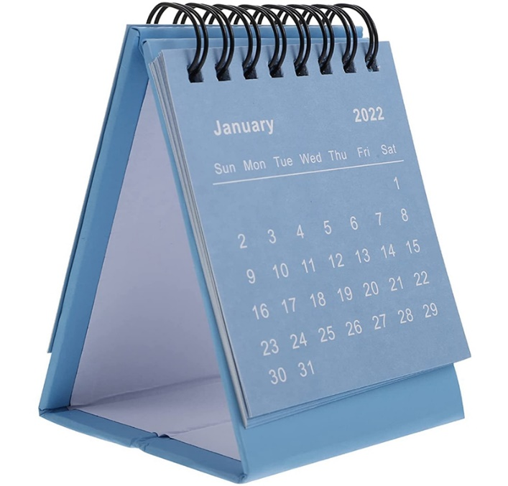**TABLE CALENDAR**RYANA CALENDARS is selling wonderful CALENDARS! at reasonable prices. It has perfect designs and color combinations.

**RS 230**